Comparable Rocket Case Study

Maryland Space Grant Consortium

Summer Exchange 2019

Morgan State University

Micah Nissly

Mentor: Dr. Guangming Chen

July 1, 2019

1. **Copenhagen Suborbitals - *Nexø I*:**

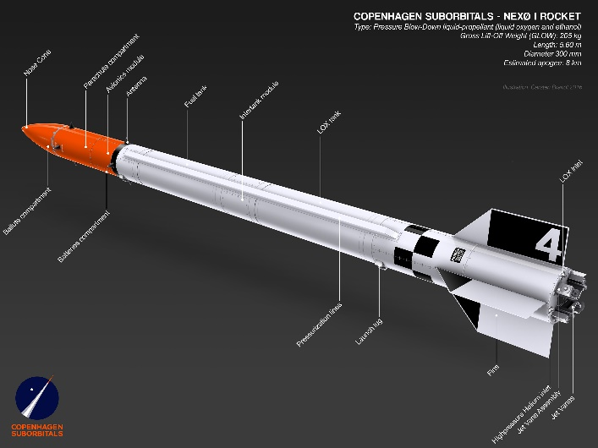 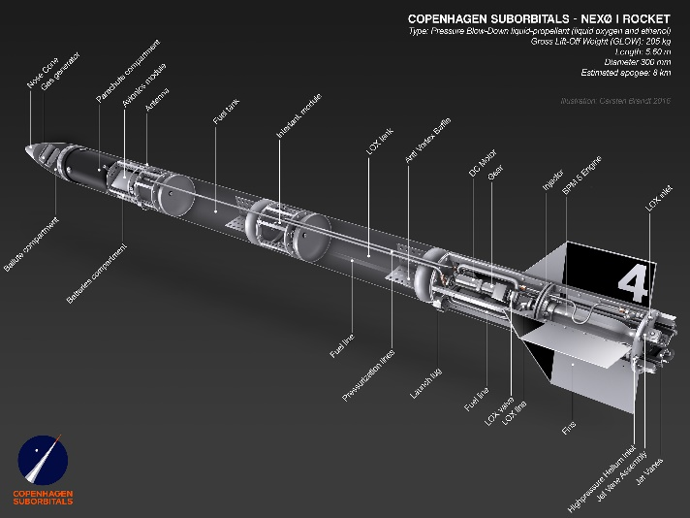

*Figure 1: Nexø I Diagram with and without Cutaway*

* **Propulsion System:** Liquid Bipropellant
  + Oxidizer: Lox
  + Fuel: Ethanol
  + Feeding: Pressure Blowdown
  + Ignition: pyrotechnic igniter
  + Cooling:Yes
* **Guidance:** Active - Gimballing; Passive - Fins
* **Length:** 5.6 m (~18.4 ft)
* **Diameter:** 300 mm (~12 in)
* **L/D:**18.67
* **Fins:**Clipped Delta
* **Apogee:** Estimated – 8 km, Actual – 1.5 km
* **Mass:** 
  + **GLOW:** 205 kg
  + **Dry:**  kg
* **Notes/Takeaways:** This rocket was the first liquid bipropellant rocket to be launched by Copenhagen Suborbitals and is included to show a rocket not developed by college students. The rocket failed to reach its projected apogee because of an engine valve malfunction that greatly decreased the thrust produced. Good things to take away from this rocket are the viability of ethanol/Lox as a good propellant combo and relative reference geometries

1. **Copenhagen Suborbitals - *Nexø II*:**

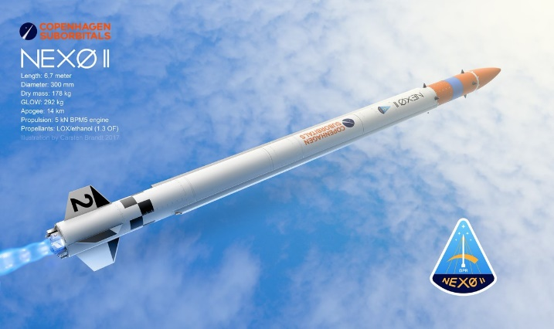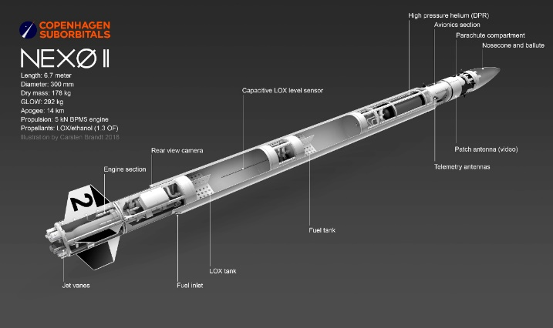

*Figure 2: Nexø II Diagram with and without Cutaway*

* **Propulsion System:** Liquid Bipropellant
  + Oxidizer: LOx
  + Fuel: Ethanol
  + O/F:1.3
  + Thrust: 5 kN
  + Feeding*:* Dynamic Pressure Regulation (auxiliary He tank)
  + Ignition:Pyrotechnic igniter
  + Cooling: Yes
* **Guidance:** Active - Jet Vanes; Passive - Fins
* **Length:** 6.7 meters (~22 ft)
* **Diameter:** 300 mm (~12 in)
* **L/D:**22.33
* **Fins:**Symmetrical Trapezoid
* **Apogee:** 14 km (~46 kft)
* **Mass:** 
  + **GLOW:** 292 kg
  + **Dry:** 178 kg
* **Notes/Takeaways:** Second liquid rocket launched by CS. Much higher apogee. A few feet longer than Nexø I, but the same diameter. Gives another propellant delivery system option (Dynamic Pressure Regulation). Used different fin shape than Nexø I. Unfortunate part of Nexø I and II is that tank lengths and other more intimate rocket details are unavailable.

1. **Space Concordia – *Supersonice***

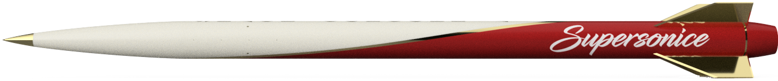

*Figure 3: Supersonice rendering*

* **Propulsion System:** Solid
  + Motor: Cesaroni Pro 98 (N-Class)
* **Guidance:** Passive - Fins
* **Length:** 10 ft
* **Diameter:** 6 inches
* **Fins:**Clipped Delta
* **L/D:**20
* **Apogee:** 30,000 ft
* **Mass:** 
  + **GLOW:** 77.98 lbs
  + **Dry:** 45.29 lbs
* **Notes/Takeaways:** While this is a solid rocket and not much can be taken from the propulsion system, Space Concordia documented their manufacturing process and structural analysis well. Additionally, the rocket is of a similar size to the one being designed, so many of the manufacturing techniques (i.e. mandrels for composite airframe wrapping, etc.) are directly applicable.

1. **UC, San Diego – *Vulcan I***

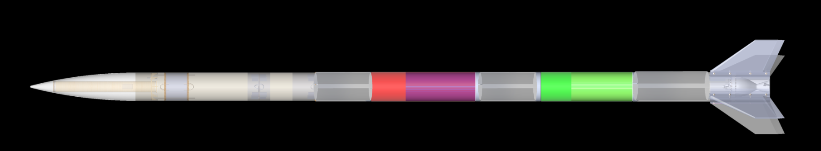

*Figure 4: Layout diagram of Vulcan I*

* **Propulsion System:** Liquid Bipropellant
  + Oxidizer: LOx
  + Fuel: RP-1
  + O/F:unknown
  + Tank Pressure:860 psi (fuel), 900 psi (ox)
  + Thrust: 3336 N
  + Feeding*:* Pressure Blowdown
  + Ignition:unknown
  + Cooling: Yes
  + Engine Specs: [SRAD Ignus Engine]
    - Material – Inconel 718
    - Diameter – 8 inches
    - Height – 10 inches
    - Chamber Pressure – 400 psi
* **Guidance:** Passive - Fins
* **Length:** 19 ft
* **Diameter:** 8 inches
* **L/D:**28.5
* **Fins:**Back Swept Trapezoidal (fiberglass with foam core)
* **Apogee:** 4,000 ft
* **Recovery:**28 ft main chute and 10 ft drogue chute attached using series of bulkheads with u bolts
* **Mass:** unknown
* **Notes/Takeaways:** This rocket is interesting because it used a 3D printed Inconel engine (first of its kind on the collegiate level. It also has a well-developed liquid propulsion system. The rocket surprisingly has a low apogee, but I believe that it is due to the rocket being poorly optimized for weight. The avionics bay of this rocket was housed in the nosecone. Nosecone was attached via shoulder, not a coupler and it seems as if it was friction-fit, rather than using shear pins.

1. **UC, San Diego – *Vulcan II***



*Figure 5: Skeleton of Vulcan II*

* **Propulsion System:** Liquid Bipropellant
  + Oxidizer: LOx
  + Fuel: RP-1
  + O/F:[insert]
  + Thrust: 3559 N
  + Feeding*:* unkown
  + Ignition:unknown
  + Cooling: Yes
  + Engine Specs: [SRAD Ignus II Engine]
    - Material – Inconel 718
    - Diameter – 8 inches
    - Height – 10 inches
* **Guidance:** Passive – Fins
* **Length:** unknown
* **Diameter:** 8 inches
* **L/D:**unknown
* **Fins:**Back Swept Trapezoidal
* **Apogee:** Goal – 45,000 ft. Not yet flown
* **Mass:** unkown
* **Notes/Takeaways:** A lot is unknown about this rocket because it is still under development. It looks like it uses a Dynamic Pressure Regulation feeding system. Engine is optimized version of the one used on Vulcan I. Similar in scale and scope to Vulcan I, but much more optimized and aiming for a MUCH higher altitude.

1. **Portland State Aerospace – *LV2.2 (Launch 12)***

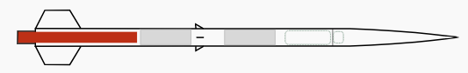

*Figure 6: LV2.2 Schematic*

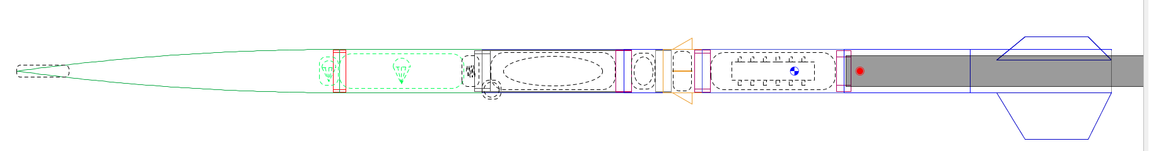

*Figure 7: LV2.2 OpenRocket*

* **Propulsion System:** Solid (Cesaroni N2501)
  + Thrust: 2501.8 N
* **Guidance:** Fins
* **Length:** 3.35 m (~11 ft)
* **Diameter:** 5.5”
* **L/D:**24
* **Fins:**Trapezoidal (and had small mid-body delta fins)
* **Apogee:** 4.7 km (~15,420 ft)
* **Mass:** 
  + **GLOW:** ~34 kg (~75 lbs)
* **Notes/Takeaways:** Modular Aluminum Body sections with Fiberglass Aeroshell. Proven and optimized design (was used in 7 flights). Design included in case study because Portland State is now early in the design process of a liquid rocket and much has been taken from that documentation. This rocket has reached a very similar altitude to the one being design for and so structurally its design is useful. Additionally, this design has reached transonic and supersonic speeds, which is projected for the one being designed, so there is some useful aerodynamic information. This rocket also includes spin-dampening which is an interesting concept to explore.

Also, this rocket has an accessible OpenRocket file which is extremely valuable for simulation help.

1. **UCLA Rocket Project – *Ares***

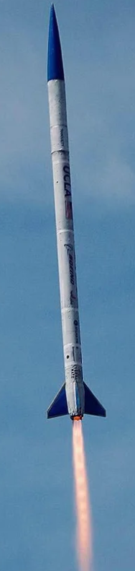

*Figure 8: Ares in flight (April 2019)*

* **Propulsion System:** Liquid
  + Oxidizer: LOx
  + Fuel: Ethanol or Kerosene
  + O/F:unknown
  + Thrust: 3114 N
  + Feeding*:* unknown
  + Ignition:unknown
  + Cooling: unknown
* **Guidance:** Fins
* **Recovery:**two-bay dual deployment
* **Length:** 15.2 ft
* **Diameter:** 7 inches
* **L/D:**26
* **Apogee:** Aim: 40,000-45,000 ft, Current (14,600 ft [and Mach 1.3] in April 2019)
* **Structure:**Semi-Monocoque – the structural strength is derived in part by the aeroshell, but also has some traditional internal structural elements too.
* **Mass:** unknown
* **Notes/Takeaways:** In 2017-2018, UCLA used Ares to set the collegiate apogee record for a liquid powered rocket at 12,500 ft. They have continued to develop this rocket, specifically focusing on structural improvements and more advanced propulsion technologies, so this rocket is definitely one to keep an eye on. In April 2019 they launched it at the FAR-MARS competition, with an estimated performance of 45,000 ft, but they lost telemetry at 14,600 ft and did not recover the rocket.

1. **UCLA Rocket Project – *Prometheus***

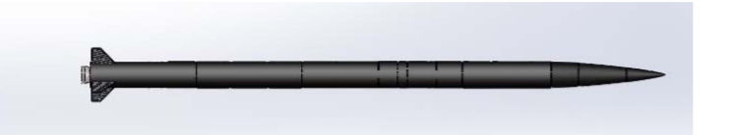

*Figure 8: Prometheus Model*

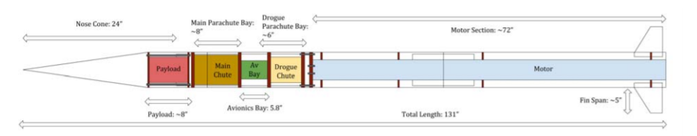

*Figure 9: Prometheus Diagram*

* **Propulsion System:** Hybrid
  + Oxidizer: Liquid Nitrous Oxide
  + Fuel: Paraffin wax/HTPB mixture
  + Thrust: 1757 N
  + Feeding*:* Pressure blowdown
  + Ignition:Ignition charges
  + Cooling: No
* **Guidance:** Fins
* **Airframe:**three layers of woven pre-impreg CF reinforced plaster. Manufactured with aluminum mandrel.
* **Nosecone:**LD Haack profile with fineness ratio of 4. Designed using balance of mass reduction and drag reduction
* **Length:** 10 ft 11 inches
* **Diameter:** 6.08 inches
* **L/D:**21.55
* **Apogee:** 8600 ft
* **Mass:** 
  + **GLOW:** 58.8 lbs
  + **Dry:** 46.2 lbs
* **Notes/Takeaways:** Couplers made by cutting body tubes lengthwise and sanding down the edges to reduce diameter. Used equations of circular plate that is centrally loaded for bulkhead calculations. Thrust bulkhead thickness was calculated with factor of safety of 2 (Max thrust of motor burn recorded). Calculated body tube thickness with force analysis (both axial stresses and pressurization for chutes (also considered porosity).

1. **University of Washington – *SARP Rocket 2019***

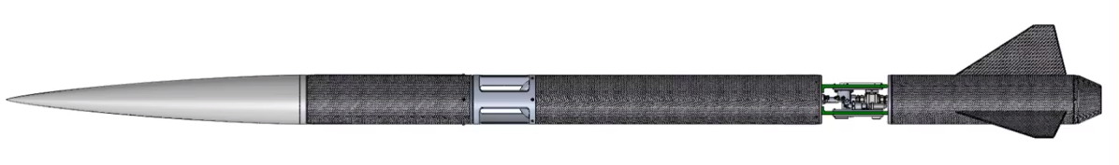*Figure 10: SARP Rocket Structures CAD*

**Propulsion System:** Hybrid

* + Oxidizer: Nitrous Oxide – COPV tank
  + Fuel: Paraffin Wax (solid)
  + Thrust: 1200 lbf (5338 N)
  + Feeding*:* Pressure blowdown
  + Ignition:Unknown
  + Cooling: None, but designed nozzle with insulation
  + Nozzle:Multi-material, but exit is graphite
* **Guidance:** Fins
* **Airframe:**Carbon Fiber prepreg manufactured with aluminum mandrel, but one airframe section is aluminum. Used classical laminate theory to design CF layup
* **Nosecone:**Von Karman with 5.95:1 fineness ratio
* **Fins:**Clipped delta
* **Length:** 14’8”
* **Diameter:** 7.9”
* **L/D:**22.3
* **Apogee:** ~30,000 ft
* **Mass:** 
  + **GLOW:** unknown
  + **Dry:** 132.5 lbs (with payload)
* **Notes/Takeaways:** The SARP team did very good structural analysis on their rocket, providing a good method for me to go forward with structural analysis. Additionally, a lot of detail in specific design elements helps with detailed design for this rocket.

1. **University of Waterloo – *Unexploded Ordinance***

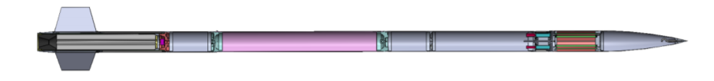

*Figure X: UXO Sectional View*

* **Propulsion System:** Hybrid
  + Oxidizer: Nitrous Oxide
  + Fuel: hydroxyl-terminated polybutadiene (HTPB)
  + Thrust: unclear
  + Feeding*:* Pressure
  + Ignition:Electric (nichrome coil)
  + Cooling: none
* **Guidance:** Fins
* **Length:** 178 inches (14’ 10”)
* **Diameter:** 6 inches
* **L/D:**29.67
* **Nosecone:**Tangent Ogive with 4:1 fineness ratio (fiberglass body with aluminum tip)
* **Fins:**3 fins, trapezoidal shape w/ 12” root cord and fillet welded to an aluminum fin can. 1/8” thick with chamfer on leading and trailing edges.
* **Apogee:** 13,412 ft
* **Mass:** 
  + **GLOW:** 141 lbs
  + **Dry:** 103 lbs
* **Notes/Takeaways:** Design ideology for this rocket was a modular design permitting rapid assembly and disassembly of individual subsystems. The design report for this rocket has a lot of details about the design process which is very helpful.

1. **MIT – idk what it’s called**

* **Propulsion System:** [insert]
  + Oxidizer: [insert]
  + Fuel: [insert]
  + O/F:[insert]
  + Thrust: [insert]
  + Feeding*:* [insert]
  + Ignition:[insert]
  + Cooling: [insert]
* **Guidance:** [insert]
* **Length:** [insert]
* **Diameter:** [insert]
* **L/D:**[insert]
* **Apogee:** [insert]
* **Mass:** 
  + **GLOW:** [insert]
  + **Dry:** [insert]
* **Notes/Takeaways:** [insert]

1. **CSULB Beach Launch Team – *Beach 1***

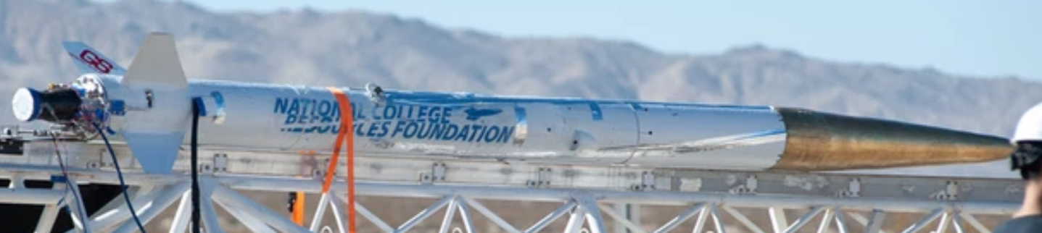

*Figure X: Beach I loading on launch rail*

* **Propulsion System:** Liquid Bipropellant
  + Oxidizer: LOx
  + Fuel: Liquid Methane
  + O/F:unknown
  + Thrust: unknown
  + Feeding*:* Pressure blowdown presumed
  + Ignition:unkown
  + Cooling: Ablative
* **Guidance:** Fins
* **Airframe:**Some composite layup on an aluminum mandrel
* **Nosecone:**Unknown shape. Has blunted aluminum tip
* **Fins:**Clipped Delta with apparent wedging on leading and trailing edges
* **Length:** unknown
* **Diameter:** unknown, but large, probably 10-12 inches
* **L/D:**unknown
* **Apogee:** unknown
* **Mass:** unknown
* **Notes/Takeaways:** Designed for FAR-MARS. Unique because they use liquid methane. Not a ton of detailed design info available though. Used COPVs for propellant tanks

1. **Purdue Rocket**

* **Propulsion System:** [insert]
  + Oxidizer: [insert]
  + Fuel: [insert]
  + O/F:[insert]
  + Thrust: [insert]
  + Feeding*:* [insert]
  + Ignition:[insert]
  + Cooling: [insert]
* **Guidance:** [insert]
* **Length:** [insert]
* **Diameter:** [insert]
* **L/D:**[insert]
* **Apogee:** [insert]
* **Mass:** 
  + **GLOW:** [insert]
  + **Dry:** [insert]
* **Notes/Takeaways:** [insert]

1. **Delft Aerospace Rocket Engineering – Stratos I-IV**

Sources

1. <https://copenhagensuborbitals.com/missions/nexo-i/>
2. <https://copenhagensuborbitals.com/missions/nexo-ii/>
3. []
4. []
5. []
6. []
7. []
8. []
9. []
10. []
11. []
12. []